**Open: New Note > “BENEFICIARY TRAVEL (BT)”**

**Please have pt’s **destination address** ready when you start this note.**

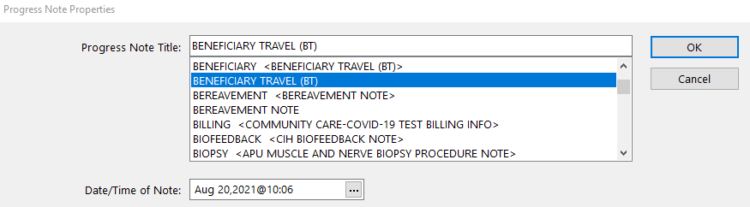

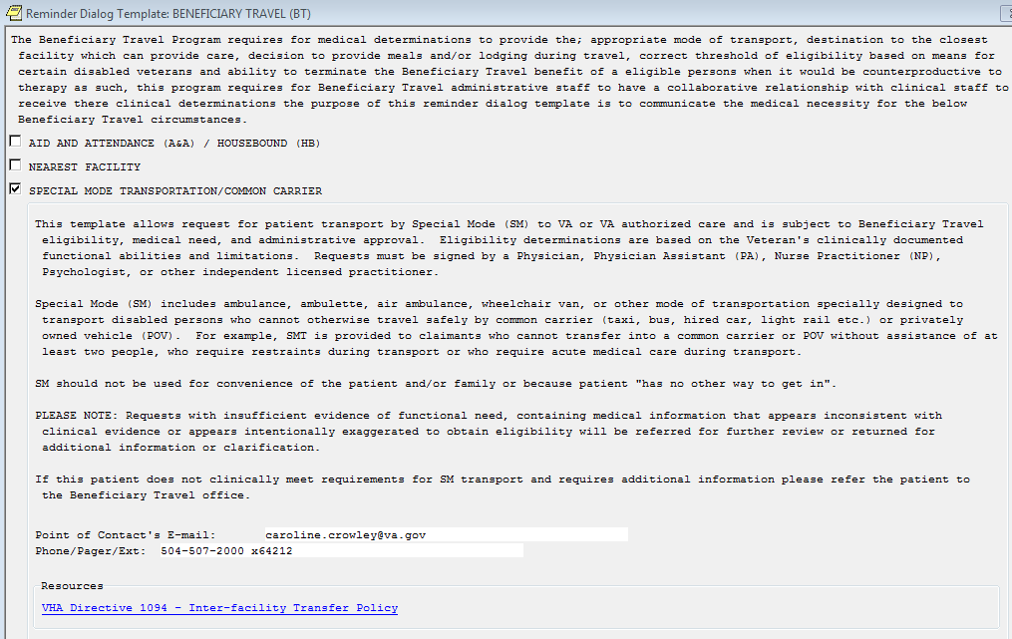

🡨 not required

This may not be a required filed

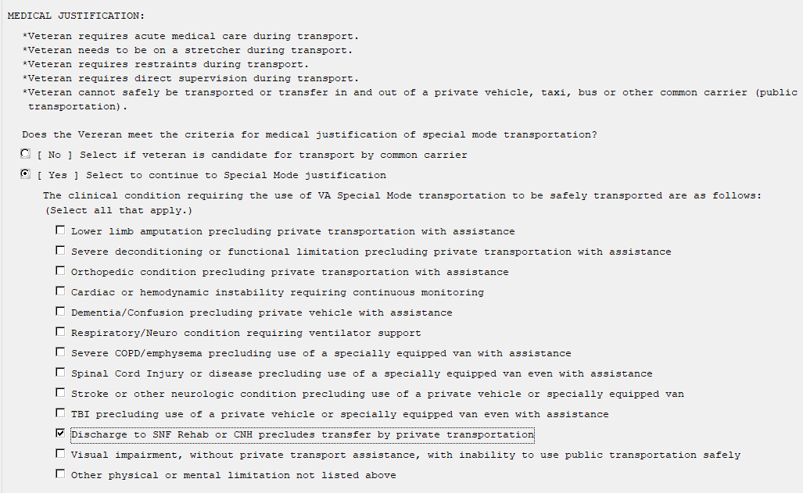

🡨 or choose “Other…” & fill in **medical** reason for transport. *(FYI “Homeless” is NOT a good diagnosis.)*

**If local **VTS van** (not *ambulance*/ *wheelchair van*) just type “VTS” in the OTHER category; no diagnosis needed.

Check off a

diagnosis 🡪

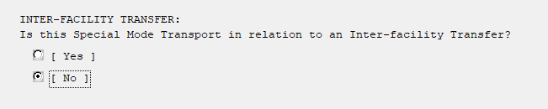

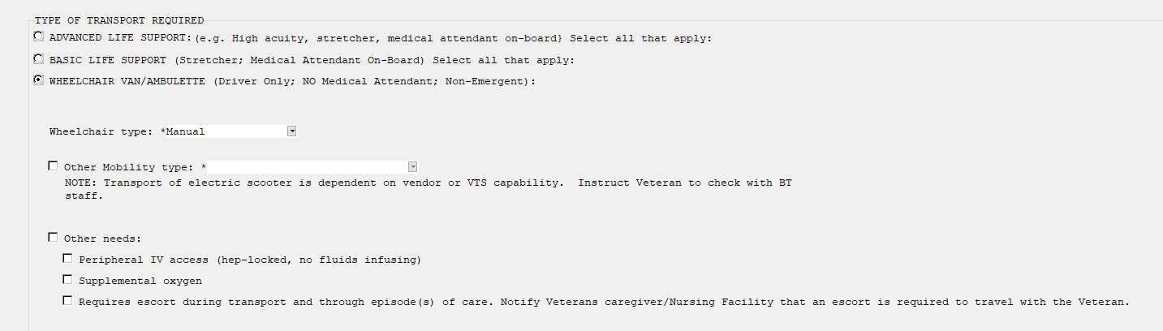

Check if needs O2 🡪

🡪 For **ambulance** you can put “*Unable to maintain sitting position for duration of ride*.” Or if the pt has a decubitus, write “*decubitus*” & it’s stage.

If **wheelchair van**, choose “manual wheelchair” if pt’s personal wheelchair is not with the pt.

If local **VTS van**, just choose *wheelchair van* option, since there is not a *VTS* option listed.

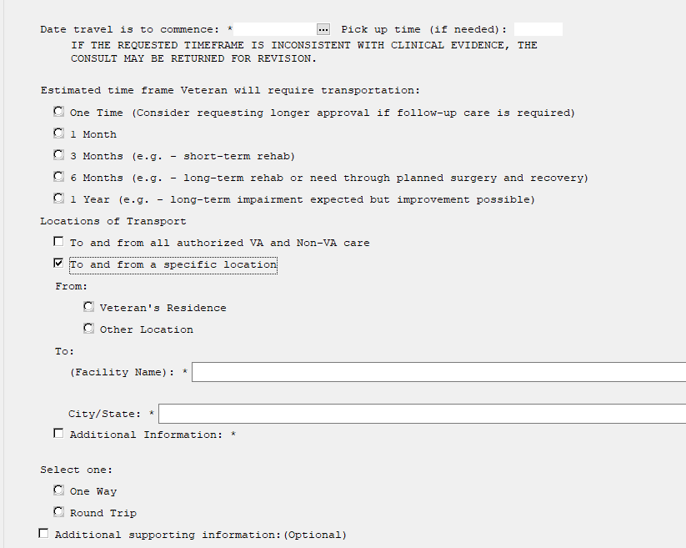

🡨 note: Pt’s home address can be found on their **face sheet** when you click on their name at top of CPRS & **can be opened while you have this screen open**. (confirm with pt their address)

SLVHCS: 2400 Canal St., New Orleans, LA 70119, **room ###**

…..OR ↓ if “**Advanced Life Support**” selected:… but usually we never use this!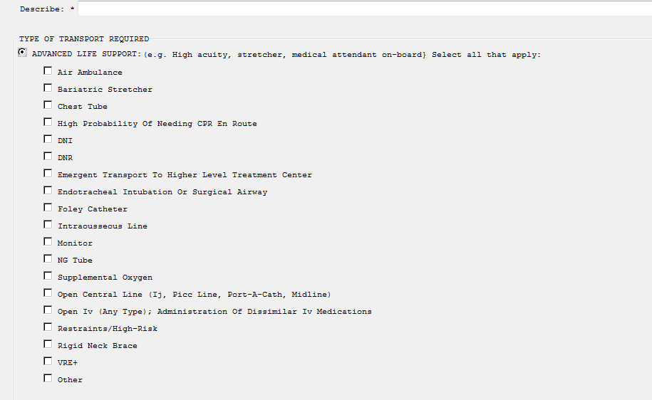

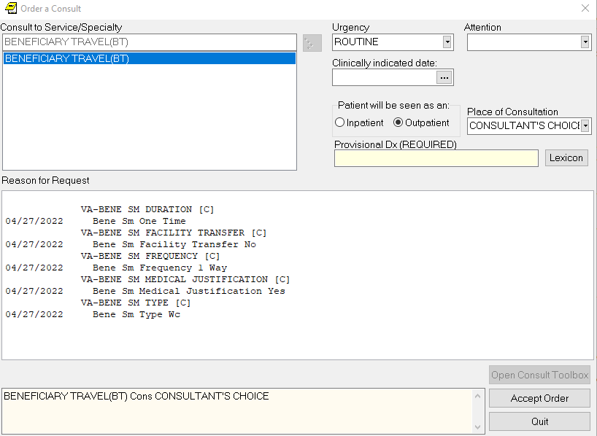



1. In the top drop-down box “**Attention**” alert “**KEN WEISGARBER**” in Travel.
2. FINAL SCREEN put the **diagnosis** in the “Provisional Dx” box. (If googling an ICD-10 codeyou’re your diagnosis helps, you can type that # in instead of words.)
3. Click “**Accept Order**” at bottom.
4. Then it will require you to **sign it TWICE**. If it doesn’t prompt you to sign it, go to the top toolbar and click *FILE > REFRESH PATIENT INFORMATION* and it will ask you to sign it twice.
5. Once it is completed, RIGHT CLICK, choose “**Identify Additional Signers**” and add  ***Cynthia Berfect.*** *This will alert them all immediately so that they can call and arrange the ride.*
6. **Communicate with your social worker** as to who needs to email *VHANOL Beneficiary Travel*, so Travel knows who to call when it’s set up. \***AFTER 4PM call AOD x62287, don’t email Travel\***